Challenge: task 1
1. Launch one AWS ec2 and install Jenkins
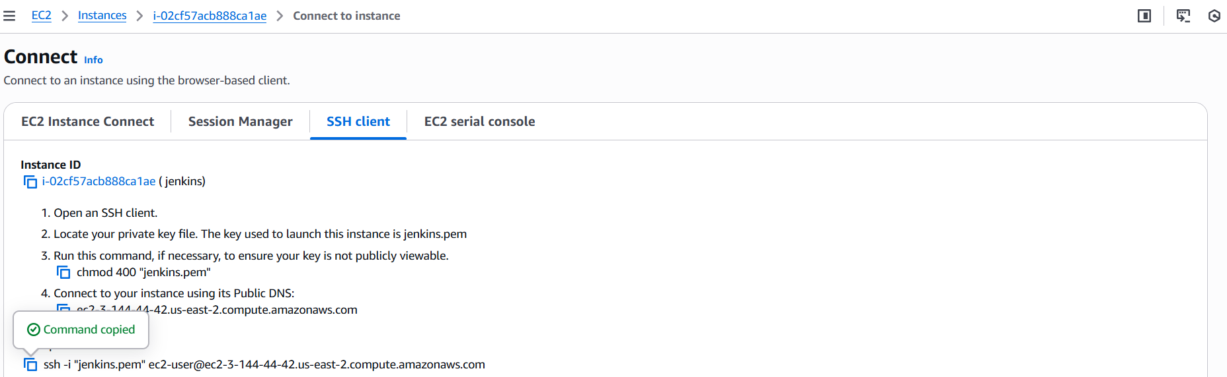

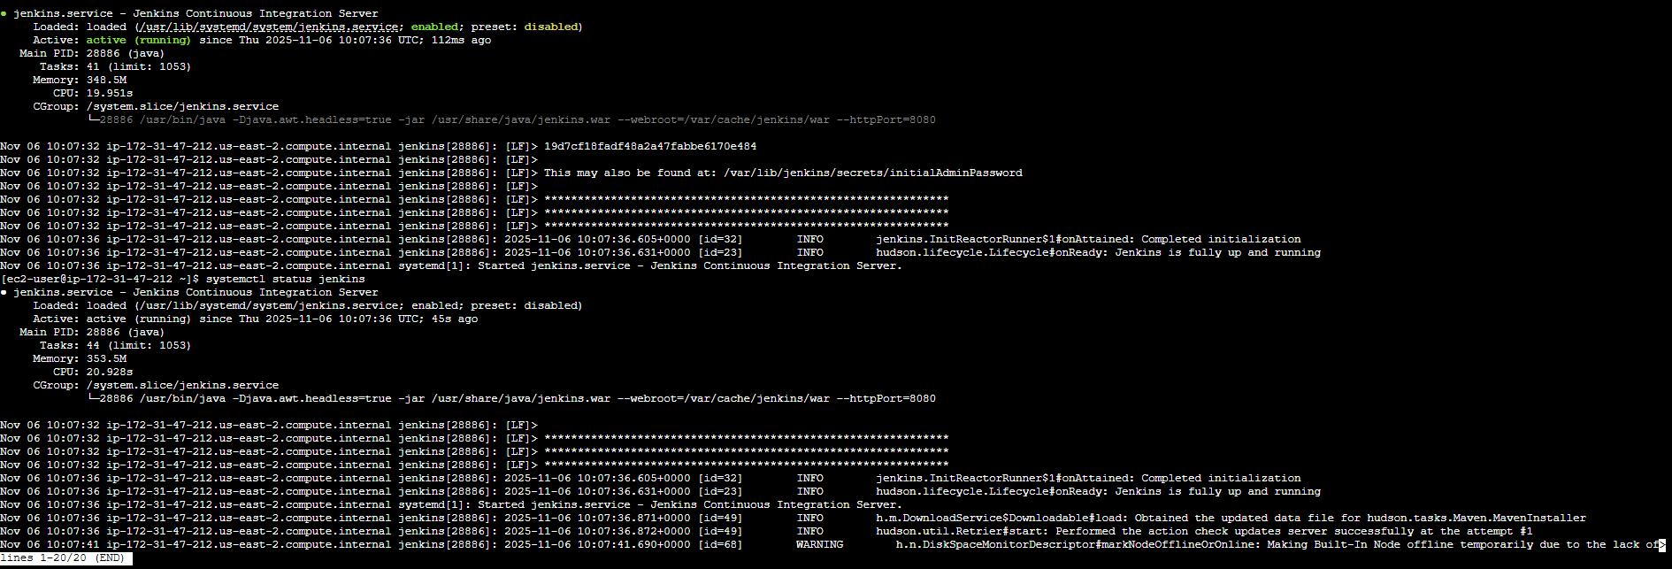

2. Setup Apache Tomcat on Ubuntu Virtual Machine
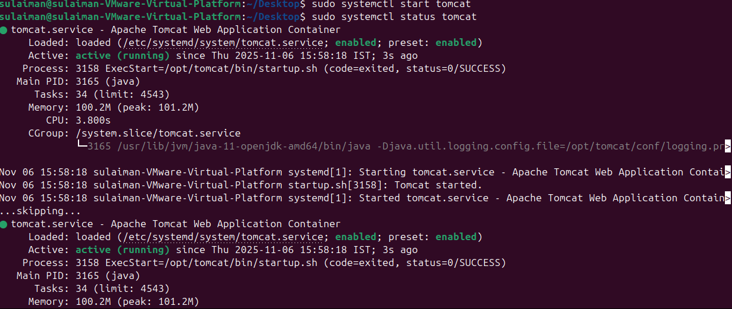

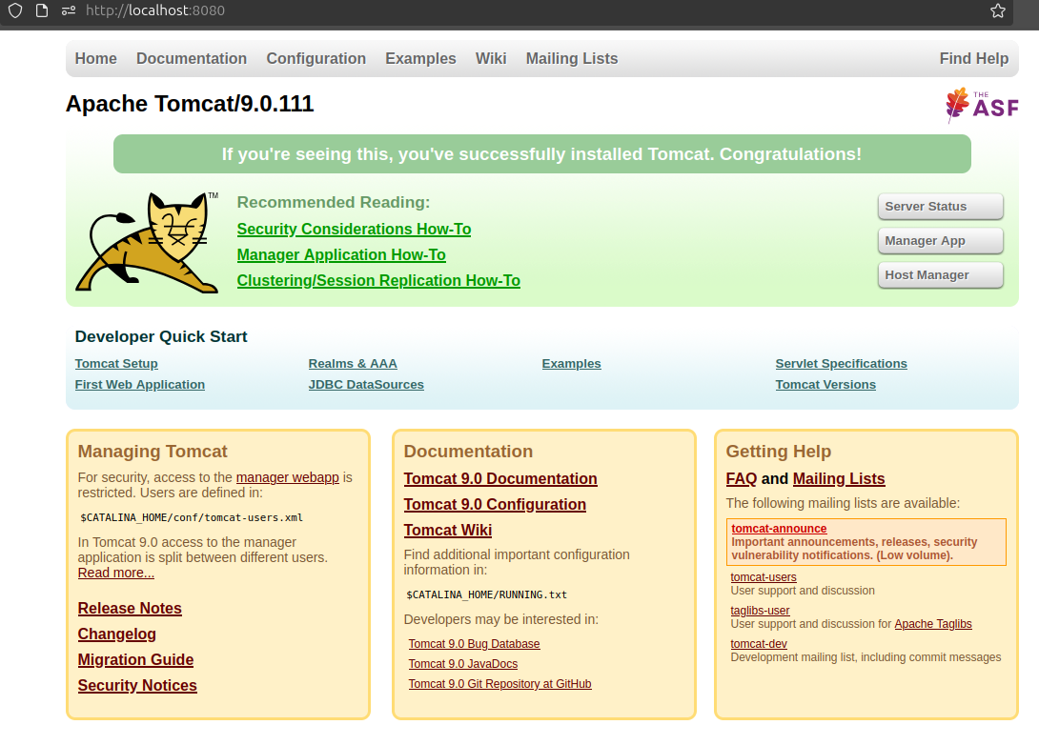

3. Setup Docker Desktop on your local windows
